**The Final Project of Business Management: PETCH**

**郭佳迎 黄秋宇 罗天泽 刘思雅 蒲舒曼**

**王琪尧 王艺煊 徐英博 袁梦瑶 詹睿雪**

**Bachelor Business of administration, Macau University of Science and Technology**

**Contemporary management D2**

**Group 13**

**Mrs. Veronica Fong**

**May 5, 2023**

**CONTENT**

1 **Introduction** 4

1.1 General Background 4

1.2 Product Performance 4

2 **Company Organizational Structure** 6

3 **Strategy** 8

3.1 SWOT analysis 8

3.2 Determining the Mission and Goals 9

3.3 Formulating Strategy 9

3.4 Planning and Implementing strategy 11

4 **Organization** 11

*4.1Planning* 11

*4.2 Organizing* 12

*4.3 Leading* 14

*4.4 Controlling* 14

5 **Company's department distribution and function** 15

5.1 Market Research 15

5.2 Data Analysis 15

5.3 Human Resources 16

5.4 Marketing 16

5.5 The Public Relations Department 17

5.6 Finance 17

5.7 Outsourcing 18

6 **Summary** 18

6.1 Company issue and solution 18

6.2 Efficiency and Effectiveness 21

6.3 Manager and group members played different roles in the group. 22

7. **References** 23

**1 Introduction**

1.1 General Background

With the rapid expansion of today's world, all countries are attempting to hold a more favourable position in the international environment, resulting in intense competition among all firms in numerous industries. Being in this competitive environment for a long time has exacerbated the problem of social involution and anxiety, and it is currently a problem that we must address. The instructor company's original purpose was to provide personalized assistance to people who are incredibly anxious due to social involution in order to alleviate their worry. To that end, our organization designed and implemented a communication platform aimed at "relieving social anxiety." Offer individuals who need qualified assistance in a diversified, professional, and productive manner. This is precisely what our business's original goals were. PETCH (profession, efficiency, target communication, humanity) is the name of our company. We are dedicated to offering unique decompression routes and full landing arrangements to persons who are apprehensive. Although making a profit is this company's primary goal, inclusion in society is also taken into account. We also want to address the issue of rising social anxiety on a global scale.

1.2 Product Performance

To fulfil the needs of various clients, our company has primarily launched three sets from which customers can choose. Customers can select the best environment for their needs, budget, and personal agenda.

A set: Our company's most cost-effective set. It is appropriate for clients who have hectic timetables and do not require immediate anxiety reduction. Specifically, offer customers travel plans so that they can relax while travelling, so achieving the goal of stress relief. The visitor can choose his or her travel destination, and our organization will also supply some reference plans. After determining the destination, our company will have a dedicated team to connect with local hotels, scenic spots, and even restaurants (if the customer travelling by car has a car rental demand, our company will also arrange it according to the need), so that the customer can directly have decompression and relaxation without the need for the customer's own travel experience.

B set: The company's modestly priced set, which is chosen by the majority of the clientele. It is appropriate for clients with mild anxiety, and the average duration is half a month to one month. In addition to all of the fundamental configurations in A set, our organization will supply trained psychologists to conduct regular psychological consultations with customers in order to help them overcome their anxiety problems more effectively.

C set: The company includes a set for consumers who are really anxious. The cost is somewhat more significant. Customers are often advised to set aside one month or more to show the decompression effect more effectively. We are going to do our best to arrange an idyllic spot far from the city that is good for recuperation, and clients can also put up their inquiries that reflect their viewpoint. In addition to the basic configuration in A, we will arrange for a one-on-one private psychologist to follow up on the customer's full decompression itinerary. The schedule will be determined by the psychologist considering the customer's particular situation.

**2 Company Organizational Structure**

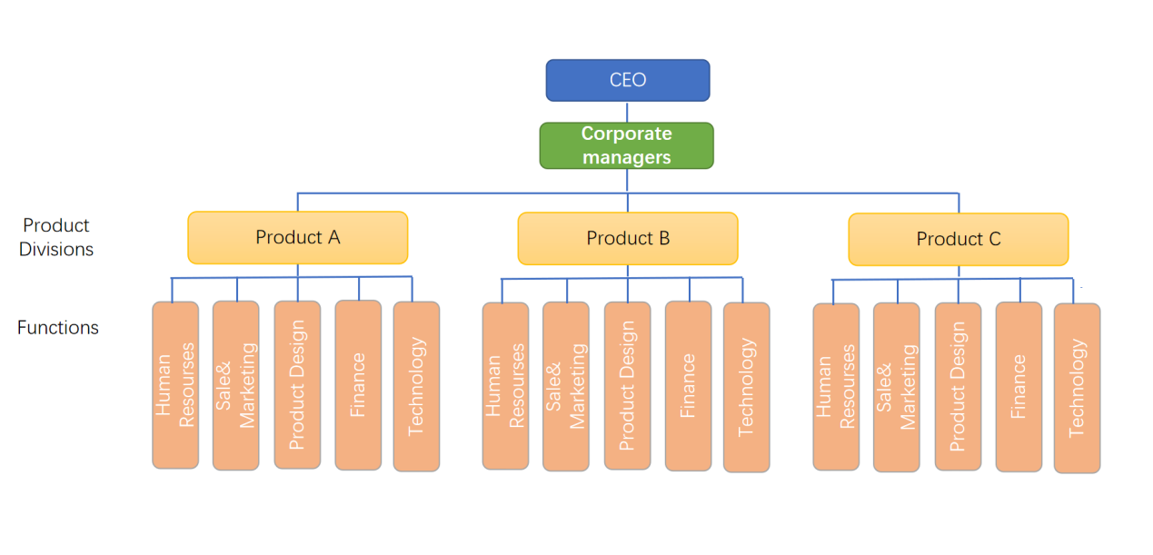

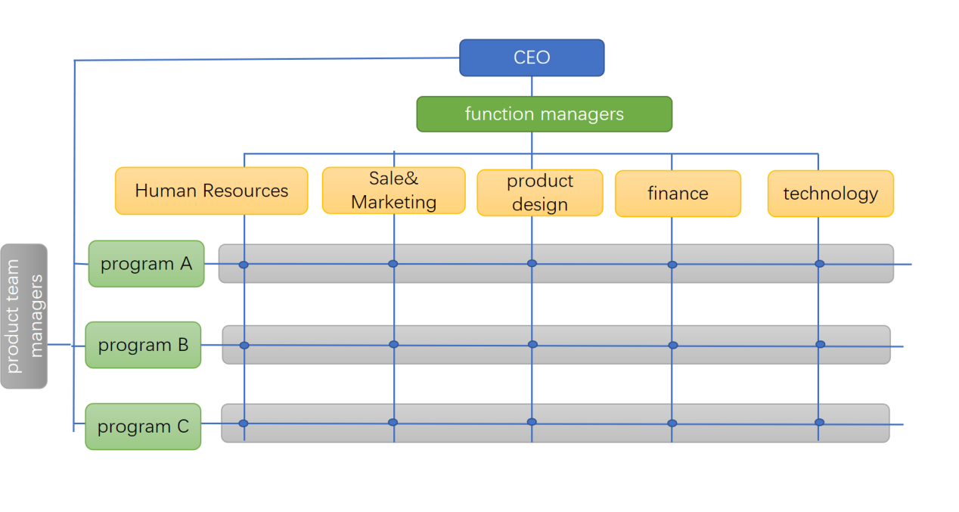

The company we work for offers three packages designed to meet the individual circumstances of our customers (their anxiety level, schedule, budget, and so on), and such packages are bound to have unpredictable events in the process of implementation due to our customers' individual differences, and our company is committed to providing quality service to each customer, so our company's structure will focus on maximizing the satisfaction of our consumers. Our structure will be designed to maximize our ability to deal with change.

In the early stages of development, our enterprise's main structure adopted the Product structure, first at the corporate level, which enables our corporate executives to develop the best corporate-level strategies to maximize the organization's ability to grow and create value in the future. Second, within this system, each division manager may become an expert in their specific field and deploy that expertise to assist them pick and implement business-level strategies to address customer needs while achieving product differentiation. Finally, the structure enables functional managers to concentrate on a single product project while also increasing the quality of their own projects. The Product structure is more attractive to selecting the best strategy in the initial phases of expansion.

When the business enters a stable growth period, we will alter the corporate framework. The flexibility and high exploitation of human resources are among the major advantages associated with this structure. We will increase our capacity for adaptation by delegating greater authority to the project managers of each package, allowing lower-level personnel to adapt to the uncertainties that may occur during project implementation more swiftly and flexibly. The matrix structure is more helpful to flexible reactions to the development process of unanticipated events during stages of smooth development.

Our company evolved out of five functional departments and three product teams that share resources and labor, illustrated in the company structure diagram, both in the early and subsequent stages. To facilitate management in the early stage, the structure in the early stage focuses at the quality of a single project, and each employee only is responsible for reporting to one leader. Each employee has two superiors in the next matrix structure, one for the product team he is responsible for and one for the functional department he works in. And the individual will be switched to a new team after finishing a certain task, ensuring that the company's resources and labor are used as efficiently as possible.

**3 Strategy**

**3.1 SWOT analysis**

|  |  |
| --- | --- |
| **Strengths** | * We have a professional psychological team to provide emotional relief services * Our company's organizational structure reduces operating costs by maximizing resource and manpower utilization |
| **Opportunities** | * With the decline of Engel's coefficient, people pay more and more attention to spiritual pleasure * After the company entered a stable development stage, we will carry out vertical integration, enter the construction of tourist resorts and psychological training companies |
| **Weaknesses** | * We will be the first company of this type, and there is no case for reference * The corporate structure of the matrix structure can lead to conflicts in the management of product teams and functional teams |
| **Threats** | * We will be the first company of this type, and there is no case for reference The corporate structure of the matrix structure can lead to conflicts in the management of product teams and functional teams |

**3.2 Determining the Mission and Goals**

In its earliest phases, the company will primarily focus on the needs of East Asians for anxiety relief and nerve relaxation. We will offer three distinct price plans to consumers, and they will be able to select the most appropriate plan based on their individual circumstances. We hope that after using our solutions, every one of our customers will feel less stressed out.

**3.3 Formulating Strategy**

*Corporate-level plan: (Multi-domestic Strategy):*

In different countries, the enterprise will sell differentiated services. East Asians are the primary consumer groups we have targeted at this stage in time. We will provide customized treatments and publicity in different places based on the reasons of concern and consumer eating patterns in China, Japan, and other countries. We can accomplish this difference by contracting with several companies.

*Business-plan (Differentiation Strategy):*

Our business will be the first to bring in highly qualified psychological staff and offer anxiety reduction services. Our company's product is beyond any other company's. We will also develop a platform for linking with clients before designing and delivering after-sales care through a professional technical staff, and we are going to continually improve the quality of our products depending on the outcomes of the communication.

*Low-cost Strategy:*

This company will utilize the most expert resources in the market through outsourcing to give the best services to customers while lowering expenses. The corporation will also use mobile personnel management. The burden of each department varies depending on the company's stage of development. We will continue to assign personnel from teams with a reduced workload to departments with a bigger workload to share some of the workload. Exploit company resources to save money.

*Function-plan Strategy (Human Resources Strategy):*

The planning and execution encourage employees to work actively and have a reward and punishment system in place. We also offer frequent staff pieces of training to strengthen our employees' skills.

*Marketing Strategy:*

The Internet and other means will be used to promote this company, so that our customer groups can understand the specific services of our company and play a role in recruiting consumers.

*Financing Strategy:*

Plan the company's capital flow prudently and maximize profitability by addressing consumer needs. Furthermore, we will embrace the opportunity to collaborate with other companies in order to establish more and more stable sources of funding for the company.

*Research and Development Strategy:*

Our company's research and development team is primarily focused on researching the demands of modern high-pressure individuals. A competent psychological medical team analyzes the stress origins of the present-day high-pressure people and innovative methods to relieve stress in order to better serve our client groups.

*Customer Service Strategy:*

When any problems emerge during the customer journey, our firm will provide appropriate resolutions as soon as possible to ensure that consumers have a positive experience throughout the service. In a short time after the service concluded, our company will keep track of the customer's psychological state in order to maximize the consequences of our service.

**3.4 Planning and Implementing strategy**

This company promises to employ a skilled psychological medical team to serve customers and give adequate compensation. We will adhere to Fayol's fourteen principles, define obligations and rights, and increase efficiency and effectiveness.

**4 Organization**

**4.1Planning**

Numerous physical and mental health issues have emerged in the post-pandemic era, according to the nation's existing external and social environment. Data collection indicates that Asia, Europe, and the Americas have serious mental health issues. Our company's objective and goal is to address each customer's unique physical and mental health issues and offer them individualized solutions to improve their physical and mental well-being. The mission statement of our business is to "Give your heart a comfortable habitat where you can experience true relaxation and inner peace."Today's external environment changes quickly. To better manage these changes, set a rolling plan based on the annual financial budget, external market changes, and scenario planning. Then, amend the plan as necessary. When the business grows gradually, it will implement the proper vertical integration, such as the company's plans to construct resort tourism regions, training facilities for psychological counselors, and other subsidiaries. We employ a strategic alliance approach for global expansion after expanding China's East Asian market, and we carry out a multinational strategy on the variations in culture, life, economy, etc. of each region and country. In the business-level plan, a differentiated strategy will be developed to deliver differentiated services by various job natures, hobbies, genders, and personal life backgrounds, and to attempt to solve personal differentiation issues.

**4.2 Organizing**

We will put up the following organizational structure to facilitate better organizational working connections and allow team members to work together and cooperatively to accomplish company goals.

*Management Team:* the management team is in charge of everyday operations management and strategic decision-making for the business, including risk management, strategic planning, and teamwork coordination. oversee and manage the day-to-day operations of the firm, make sure it is sustainable and effective, build relationships with customers, uphold its reputation, and spot new business prospects.

Human Resources Team: The team in charge of human resources is in charge of hiring, managing, and training staff. Ensure that the staff as a whole embodies the company's culture and values.

*Team of psychologists:* the company's core team members will create individualized programs for consumers, hire psychologists with various educational and professional backgrounds, and attend to the various demands of the company's clients.

*Marketing Team:* the marketing team is in charge of creating marketing plans, advertising business services, and reaching out to and maintaining relationships with new clients. A budget, financial reporting, taxation, and other financial management tasks are the responsibility of the financial team.

*Technical team:* charged with developing and maintaining the company's technical framework, creating and maintaining an online platform that allows clients to contact psychologists online, creating and maintaining tools for data collection and analysis, and managing and maintaining the IT infrastructure.

Establish an organic organizational structure for the business that encourages teamwork and quick responses to unforeseen situations. Enable enterprises to structure, integrate, and reconfigure processes in response to quickly changing internal and external contexts by strengthening their dynamic capabilities.

**4.3 Leading**

The company's vision is to become a specialized provider of mental health services that people can rely on, helping those in need relieve stress, find answers to difficulties, and enhance their quality of life through professional psychological therapy and individualized solutions.

Our business will give employees competitive pay and benefits, a welcoming, secure, and healthy work environment, as well as better facilities, in order to better inspire and empower members of the organization. We'll also try to boost employees' excitement for their jobs and feeling of community. Give staff members the chance to grow professionally, gain more self-assurance, and do their jobs more effectively. Increase employee autonomy and decision-making authority, allow employee input into corporate decision-making, and foster employee innovation. Create a positive team environment where people can trust, respect, and support one another. This will increase staff cohesion and teamwork spirit and boost productivity and quality. Increase the sense of pride and belonging among employees by giving them more praise and feedback. Create precise job descriptions and requirements, communicate these to staff, and make sure everyone understands their responsibilities within the organization.

**4.4 Controlling**

Conduct regular customer satisfaction surveys to gather input, understand customer happiness and service quality issues, and make targeted service quality improvements to raise customer satisfaction and service quality. Monitor staff performance, set performance metrics like customer satisfaction and psychological relief success rate, track and analyze metrics, identify issues quickly, create specialized training and improvement plans, and enhance employee performance. Strengthen teamwork, promote employee interaction and mutual learning, enhance organizational cohesiveness and efficiency, and guarantee the stable growth of the company's business. Maintain the firm's sustainable development, assess and summarize operating conditions on a regular basis, compile experience and lessons learned, design improvement plans, and accomplish company objectives successfully.

**5 Company's department distribution and function**

**5.1 Market Research**

The marketing strategy suggests the firm begins with consumer wants, gathers information on customer demand and purchasing power, as well as the expectations of the business community based on experience, and then organizes various business activities in a planned manner. The system is based on a membership structure, and members can take free psychological examinations. We also have a skilled team to handle one-on-one customized customization projects for top executives.

**5.2 Data Analysis**

The projects of our company are mostly directed at young and middle-aged persons who are under a lot of pressure. As stated by “Gallup's Latest Global Emotions Report，In 2021, people worldwide felt more worried, stressed and sad than at any time in the past 16 years. They also had fewer positive experiences than they did in 2020. 28% of people said they experienced a lot of sadness the previous day, the highest percentage ever recorded. 42% of people said they experienced a lot of worry the previous day, up from 40% in 2020.”(Gallup, 2023) Furthermore, according to the China Workplace Stress Report, the workplace stress index reached 7.26 in the first half of 2021, a new high in the previous four years, despite the uncertain market environment. The bigger the income after more than 400,000, the greater the sense of strain.

**5.3 Human Resources**

Our company effectively uses relevant human resources inside and outside the organization through recruitment, selection, training, remuneration, and other management forms to meet the current and future development needs of the organization and ensure the realization of organizational goals and the development of members, guided by economics and people-oriented thinking. maximize. Interviews with employee representatives, employee behavior observation, and the acquisition of historical work experience are the most commonly employed in the recruitment process.

**5.4 Marketing**

Understand the market dynamics of similar products through market research and openly imagine the development trend of future products considering changes in market information (imagining future products and providing design ideas for the production department); do a good job in all research projects before, during, and after product sales, form a research report, and provide the basis for the marketing manager to design a strategic plan.

**5.5 The Public Relations Department**

The public relations department is mainly liable for maintaining the company's positive image. The public relations department serves three primary purposes. To begin, make irregular contacts and visits with cooperative firms to verify that no mistakes are made when making arrangements for clients. Second, the public relations department will update the activity plan for each department of the company on a regular basis, report the situation to the department manager, and concentrate internal problems as soon as possible. Third, the public relations department will learn about each individual's talents and personality so that they can work in a profession that suits them while avoiding problems with others.

**5.6 Finance**

In finance, our organization will choose the low-cost option. Our organization will handle every part of running a business, from employee recruitment to client implementation. Streamline procedures, allocate resources efficiently, and eliminate waste to get work done and succeed. Create a target strategy, and we'll fine-tune a well-thought-out roadmap for budgeting and preparing for the unexpected. Increase earnings by lowering production costs and sticking to budgets.

**5.7 Outsourcing**

Companies convey non-core operations to cooperative companies in order to get a competitive edge above simply using internal resources. We initially outsourced and allowed one-on-one psychological counseling services and supporting facilities around the resort. In the beginning, we will collaborate with neighboring countries and sign agreements. If the predicted results are obtained, we will expand the market internationally and establish subsidiaries at future dates.

**6 Summary**

**6.1 Company issue and solution**

*6.1 .1Market Issue*

Due to a lack of awareness of associated industries in society, consumers require a longer adoption period. Customers may be more willing to discuss psychological issues with friends and family. Domestic customers continue to be oblivious to psychological therapy and psychological subconsciousness.

Solution: In addition to an enormous amount of commercials, public figures must encourage a company in order to reduce public anxiety.

There are disparities in the psychological necessitate of the consumer, which are difficult to identify and require a private customized plan, causing resources to be used to their full potential and exceeding the consumption threshold.

Solution: An employee can only be responsible for no more than five clients at the same time while relying on big data to develop an exclusive content library of firms to find common in the public. This is a long-term issue. The short-term solution is tough to implement. It must be dealt with in the long run.

*6.1.2 Customer-related Issue*

The nature of this project is special. The reception customers are mostly spiritually sensitive people. Customers often have a dependence on employees they are responsible for their master. However, there are still problems after a long time, but the owner is responsible for employees or cannot receive customers as soon as possible due to force majeure.

Solution: The group provides services to the customer by group. Even if the employees are responsible for the employees cannot receive customers in a short time, the remaining group members still have the ability to continue to follow up.

Since the special qualities of the company's product, the company has a big volume of user privacy data, which is difficult to control, and there is a risk of customer privacy leakage.

Solution: For data, use the company's internal network, and standardize employees' separation from work and use of equipment. Personnel must go through thorough confidentiality training before signing a confidentiality agreement.

Some customers may be required to participate in drug guidance. However, due to the distinctive traits of the company, nations have different drug management and control rules, which can easily establish problems that violate local laws.

Solution: In addition to upgrading the company's legal departments and being knowledgeable about business rules in many nations, it is also vital to be knowledgeable about medical legislation. Furthermore, collaboration with local qualified hospitals. Communicate with customers as needed and request that the hospital intervene.

*6.1.3 Management Issues*

The company's management structure is a matrix structure, which has improved technical exchanges between individuals from other departments to some extent, but it may also cause employees to lose their sense of responsibility. Employees are not accountable for the project and are prone to disagreements at handover.

Solution: Before giving assignments, leaders ought to meet with the same level members in order to optimize the reward and punishment system, the employee's responsibility for work, the work arrangements, and the management of project members.

After entering the stability era, the corporation will change its organizational structure. Internal and external pressures are both present. The corporate organizational structure may be frustrated by the superposition of all parties' factors, and even the effect of the implementation after adjustment is not as good as the original.

Solution: By reorganizing responsibilities, distributing rights, changing reporting objects, lowering levels, increasing authorization, rotation, controlling, budgeting, and so on, the division of labor among the company's members is changing the organization while changing the employee's mentality.

*6.1.4 Technical Issues*

Many nations have various common languages. As a global platform, the appropriate language must be displayed in various usage scenarios. There may be a variety of languages if there are fewer languages. When using text, the text's content must also be considered.

Solution: To achieve internationalization, 18n(Internalization) can display the corresponding interface based on the language of different countries and regions while also fixing the layout size, reducing typefaces, and making it as tiny as feasible, for globalization.

**6.2 Efficiency and Effectiveness**

We are an international company that is concerned about modern people's mental health and offers practical solutions to alleviate social anxiety in young and middle-aged people. It is designed to help young and middle-aged people deal with the stress of work and life today. At PETCH, we strive to improve the company's efficiency and effectiveness in a variety of ways, and we discussed the company's departmental operations, organizational strategy, product development, strengths and weaknesses, and improving the organizational effectiveness of the company by improving its efficiency and effectiveness. Among these, we have made changes to the company's organizational structure and chosen to use different organizational structure models at different stages of the company's development. Adopt a more flexible matrix structure after influence in order to achieve

**6.3 Manager and group members played different roles in the group.**

The CEO is the person in charge of the company's overall strategic planning, management team coordination, and market trend analysis.

The CIO is responsible for combining the organization's technology deployment plan with business strategy and assisting the CEO in fully ruling over the company's numerous management tasks.

A single individual serves as COO, develops the enterprise's long-term strategy based on the CEO's market structure research, and is responsible for the enterprise's operation and management.

A particular person serves as CFO and is in charge of the company's finances.

The chosen person will serve as CMO, defining the marketing strategy and plan of action, and promoting the marketing of the company's three primary projects.

The three are responsible for the company's three main business projects, and with the assistance of the CTO, they realize the integration of information acquisition: one individual acts as CTO, responsible for managing the entire company's technology department; and one person acts as CSO, responsible for monitoring and coordinating the company's security work.

References

Sanfilippo, M. (2023, February 22). Undue stress on workers can decrease productivity. Retrieved May 6, 2023, from <https://www.businessnewsdaily.com/8486-effects-workplace-stress.html>

Gallup, I. (2023, February 17). Global emotions report. Retrieved May 6, 2023, from <https://www.gallup.com/analytics/349280/gallup-global-emotions-report.aspx>

Bateman, T. S. & Snell, S. A. (2018), Management: Leading & Collaborating in a competitive world (13th edition). McGraw Hill

Bartol, K. M., & D. C. Martin (1998). Management (3rd edition). New York: McGraw Hill.